Colorectal Cancer:
- Stool Based Tests
These tests involve the examination of the stool for typical markers of colon cancer such as blood. Typically, these tests are non-invasive and are much more accessible and easily done than visual exams as they can be done at home, however this comes with the drawback of having to conduct more frequent tests.

Common types of this test include:
- Fecal immunochemical test (FIT)
- Guaiac-based fecal occult blood test (gFOBT)
- Multitargeted stool DNA/RNA tests

Screening frequency:
Screening should be started at age 45, and reduce your frequency around age 75, and stop completely at age 85.
Test Type | Procedure | Screening Frequency
Fecal immunochemical test (FIT) | Checks for hidden blood in the stool and can be done at home.  - No dietary restrictions are required | - Every year is recommended, starting at age 45.  - A colonoscopy is needed if the test results are positive.
Guaiac-based fecal occult blood test (gFOBT) | Checks for hidden blood in stool less accurately than the FIT test, but can be done at home.  (It doesn’t differentiate between blood from the digestive tract or from the colon)  - Requires drug and diet restrictions. | - Every year is recommended, starting at age 45  - A colonoscopy is needed if the test results are positive.
Multitargeted stool DNA/RNA tests (Cologuard) | Screens the stool for mutated sections of DNA/RNA in cancer cells, in addition to blood. This test can be done at home.  - There are no drug/dietary restrictions.  *Popular companies include Cologuard. | - Every three years, starting at age 45

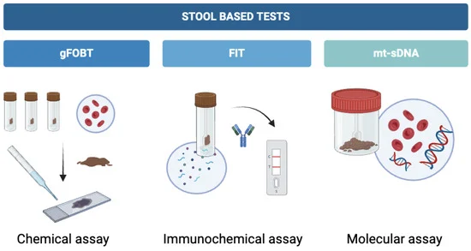
- Visual Exams
Includes an examination of the inside of the colon and rectum for cancer or polyps.
Types of this test include:
- Colonoscopy
- CT colonography (virtual colonoscopy)
- Sigmoidoscopy

Test Type | Procedure | Screening Frequency
Colonoscopy | A tube with a light and video camera is inserted through the anus into regions of the lower intestine  - Biopsies can be taken here  - Special diet/fasting required before  (Can be uncomfortable) | - Every 10 years starting at age 45  - Genetic risk factors increases frequency to every 1-5 years
CT colonography (virtual colonoscopy) | X-rays and CT scans take 3D pictures of the inside of the rectum/colon  - Sedation isn’t required  - Catheter is placed into rectum  - Less invasive  - Special diet/fasting required before
Sigmoidoscopy

- Stool-Based Tests
Involves examination of stool for any abnormal, small traces of blood, which could be indicators of colon cancer. These are noninvasive tests that can be done at home, but need to be done regularly to see any developments over time.
- Fecal immunochemical test (FIT)- basic test checking for blood traces in stool
- Guaiac-based fecal occult blood test (gFOBT)- requires a chemic reaction in order to detect any potential hidden blood in stool; less specific than FIT and could involve dietary restrictions before completion
- Multitarget stool DNA test (FIT-DNA)- checks for both blood and abnormal DNA from cancer or polyp cells and can be done at home


Screening Frequency:

Fecal immunochemical test (FIT)
- Age 45 → annual
- If results come back positive → follow up with colonscopy

Guaiac-based fecal occult blood test (gFOBT)
- Age 45 → annual
- If results come back positive → follow up with colonscopy

Multitarget stool DNA test (FIT-DNA)
- Age 45 → every 3 years
- If results come back positive → follow up with colonscopy

- Visual Exams
These tests give visualization inside the colon and rectum of the patient to check for any abnormal areas that might mean cancer or polyps.
- Colonoscopy- Rectum must be emptied prior to examination. Patients are sedated, and a long tube with a camera attached is inserted into the rectum in order to examine its entirety. May cause temporary discomfort afterwards.
- Sigmoidoscopy- similar to a colonsocopy but rather than examinging the entire colon, it only examines the lower part. Specifically, it is nserted in through the anus, than goes through rectum, and it is then moved into the lower part of the colon.
- CT Colonography (Virtual Colonoscopy)- Uses CT imaging in order to produce detailed visuals of the colon. It does not require sedation and is less invasive than a colonoscopy. Requires the bowel to be empties prior and during the procedure, a small catheter will be placed into the rectum to fill your colon with air or carbon dioxide, which will lead to clearer imaging.

Screening Frequency:

Colonoscopy
- Age 45 → every 10 years

Sigmoidoscopy
- Every 5 years

CT Colonography (Virtual Colonoscopy)
- Every 5 years

- Blood- Based Tests
These tests look for any possible signs of colorectal cancer or pre-cancerous polyps by examining a persons blood. Done in a clinic where your blood is drawn and then sent to a lab. In the lab it will look for any DNA changes that could potentially suggest the presence of cancer or pre-cancer cells.
- Shield
- ColoHealth (previously Epi proColon)

Screening Frequency for average risk patients:
- Ages 50–85 → every 3 years

For more information:
American Cancer Society

An average risk patient is someone who does NOT have:
- A personal history of colorectal cancer
- An inflammatory bowel disease
- A strong family history of colorectal cancer
- Any genetic syndromes

A high risk pateint is one that:
- Has a personal history or colorectal cancer or polyps
- Has any immflamatory bowel disease
- Has a strong family history of the cancer
- Has genetic syndromes that link them to colorectal cancer

Prostate Cancer:
- Prostate-Specific Antigen (PSA) Blood Test
This involved taking a blood test that will measure the levels of PSA which is a protein made by cells in the prostate gland. PSA is primarily comprised of semen but you can also find small traces of it in the blood. The higher the levels to increased chances or prostate cancer or prostate-related conditions. However, it is important to note that no set cutoff point can tell for sure if a man does or does not have prostate cancer. Test involes just a simple blood draw done at a clinic.

Screening Frequency (average-risk patient):
- Ages 50-69 → biannual to annual depending on PSA levels
- Not routinely recommended under age 50 or over age 70 unless advised by a doctor
Screening Frequency (high-risk patient):
- Ages 40-45 → every 1-2 years

PSA Levels
- Most men that do not have prostate cancer will have levels that fall under 4 ng/mL of blood
- Having a level between 4 and 10 is equivalent to having a 1 in 4 chance of having prostate cancer
- If PSA level is greater than 10 that means that the chances of that man having prostate cancer is above a 50%

- Digital rectal exam (DRE)
Involves a healthcare provider/doctor inserting a gloved, lubricated hand into the rectum in attempts to feel and abnormal bumps or hard areas on the prostate that could indicate prostate cancer. May cause, brief, mild, discomfort.

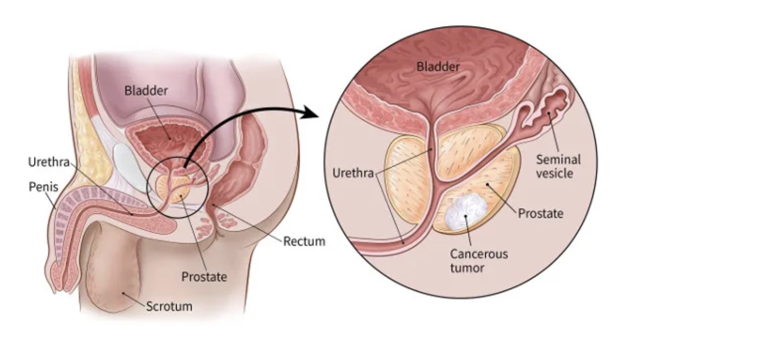
Screening Frequency
- Often occurs at the same time as PSA testing
- Frequency cannot be determined without consulting a doctor who will factor in the risk factors

Additional Information:
American Cancer Society

An average-risk patient is someone who does NOT have:
- A family history of prostate cancer
- African ancestry
- Any known genetic mutations that are linked to prostate cancer

A high-risk patient is someone with:
- A strong family history of prostate cancer
- African ancestry
- Known genetic mutations

Lung Cancer:
- Low-Dose CT Scan (LDCT)
Involved the usage of small amounts (low doses) of radiation in order to create detailed images of the lungs. The procedure is painless, noninvasive, and only takes a few minutes.
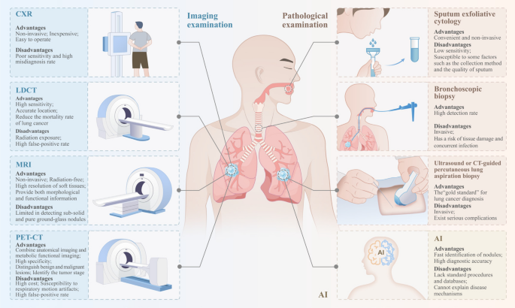
Screening Frequency (high risk patient):
- Ages 50 to 80 years → once every year

Who Should be Screened
- Adults between the ages of 50 and 80
- People who have a 20 pack-year or more smoking history (a pack year is one pack per day for a year)
- Current smokers or have former smoker who have quit within the past 15 years

Additional Information:
CDC: Lung Cancer

An average-risk patient is someone who does NOT have:
- Significant smoking history
- Daily exposure to lung carcinogens
- Personal history of lung cancer

A high-risk patient is someone with:
- A long history of cigarette smoking (20 pack-years+ )
- Current smoker or quit within the last 15 years
- Exposure to harmful substances

